*Highlighted part is either note to internal team or content that needs to be replaced with correct values e.g. email addresses, dates, etc.*

Below is a complete School Data Processing Agreement (DPA) template for SproutSong / SproutMentors, prepared for schools/institutions that share student, parent, teacher, counselling, academic, attendance, report, document, and AI-related data with SproutSong.

This is drafted for internal review, school onboarding, compliance tracking, and later legal finalisation. It should be reviewed by a legal professional before signing with schools.

---

SproutSong / SproutMentors

School Data Processing Agreement

Template for Schools / Institutions Sharing Student Data

Document Name: School Data Processing Agreement
Short Name: School DPA
Version: v1.0 Draft
Prepared For: Internal Review, School Onboarding, Compliance Tracking
Status: Draft — Legal Review Pending
Effective Date: To be added
Last Updated: To be added
Agreement Between:

1. [School / Institution Name], hereinafter referred to as the “School”

2. SproutSong / SproutMentors, hereinafter referred to as “SproutSong”

---

Internal Review Checklist

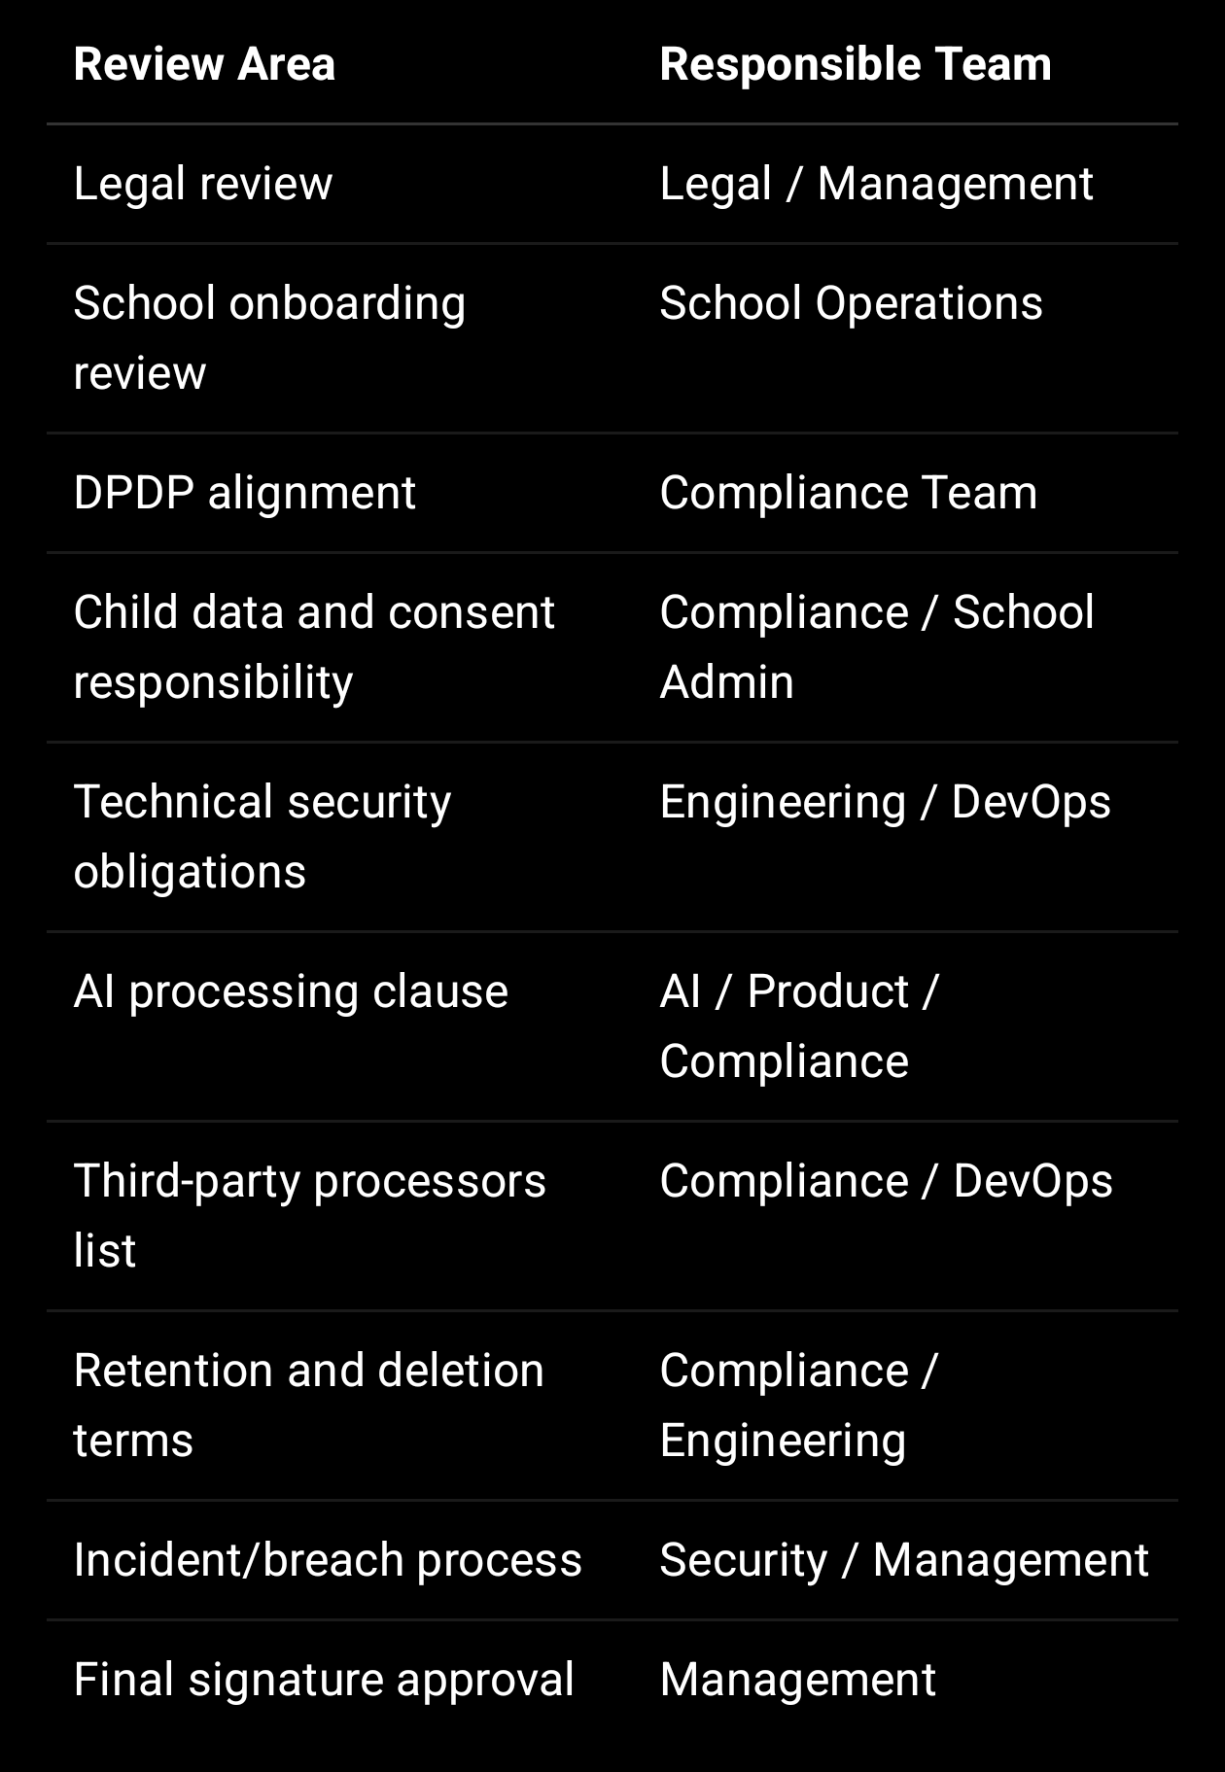

---

1. Purpose of This Agreement

This School Data Processing Agreement defines how SproutSong / SproutMentors will collect, receive, store, process, protect, use, retain, delete, and secure personal data shared by the School.

The purpose is to ensure that student, parent, teacher, counsellor, academic, attendance, counselling, report, document, and platform data is handled safely, lawfully, transparently, and only for authorised educational purposes.

SproutSong’s internal cybersecurity guidance already identifies student identity data, parent/guardian data, academic data, counselling data, attendance/behaviour data, documents, login/security data, and platform analytics as key data categories requiring protection.

---

2. Parties

2.1 School / Institution

School Name: [Insert School Name]
Address: [Insert Address]
Authorised Representative: [Name / Designation]
Email: [Email]
Phone: [Phone]

The School may include schools, colleges, coaching centres, education institutions, trusts, academies, or other education organisations using SproutSong.

2.2 SproutSong / SproutMentors

Service Provider: SproutSong / SproutMentors
Address: [Insert Address]
Authorised Representative: [Name / Designation]
Email: support@sproutsong.com
Privacy Contact: privacy@sproutsong.com
Security Contact: security@sproutsong.com

---

3. Definitions

“Agreement” means this School Data Processing Agreement.

“School Data” means data provided by the School or collected through the platform on behalf of the School.

“Student Data” means personal, academic, attendance, counselling, report, document, activity, AI-assisted, or platform usage data related to students.

“Children’s Data” means personal data of students who are below the legally applicable age of adulthood.

“Parent/Guardian Data” means parent or lawful guardian details such as name, contact details, relationship, consent, and communication preferences.

“Teacher/Staff Data” means personal, professional, academic, administrative, profile, and operational data related to teachers, mentors, counsellors, principals, or school staff.

“Processing” means collecting, recording, storing, organising, using, sharing, analysing, modifying, securing, backing up, deleting, or otherwise handling data.

“Authorised Users” means users approved by the School or SproutSong to access platform features based on role and permission.

“AI-Assisted Processing” means the use of AI, analytics, automation, or prediction tools for educational insights, reports, counselling support, recommendations, summaries, or dashboards.

---

4. Nature and Scope of Processing

SproutSong may process School Data to provide educational technology services, school management tools, counselling support, dashboards, reports, AI-assisted educational insights, communication tools, and related platform services.

Processing may include:

Student onboarding
Class and section management
Attendance tracking
Homework and assignment management
Exam and assessment management
Academic reports
Counselling and career guidance
AI-assisted educational insights
Parent-ready summaries
Principal dashboards
Teacher and mentor profile management
School operations
Communication via email/SMS/WhatsApp/platform notification
Document upload and secure storage
Platform analytics and security monitoring
Support and troubleshooting
Compliance and audit logs

SproutSong’s existing DPDP/security report identifies these purposes, including student academic management, attendance tracking, exam/assessment/report generation, parent-school communication, mentor allocation, counselling, AI-assisted educational insights, syllabus tracking, and school administration.

---

5. Categories of Data Processed

The School may share or permit SproutSong to process the following categories of data:

5.1 Student Identity Data

Name
Date of birth
Gender
Class
Section
Roll number
Admission number
School ID / student ID
Profile photo
Date of joining

5.2 Parent / Guardian Data

Parent/guardian name
Relationship to student
Phone number
Email address
Consent record
Communication preference

5.3 Academic Data

Subjects
Marks
Grades
Assessments
Exams
Homework
Assignments
Projects
Reports
Progress summaries
Teacher remarks

5.4 Attendance and Activity Data

Attendance status
Leave status
Reason category
Activity participation
Sports/extracurricular records
Class routine
Substitution information

Attendance reason data can become sensitive if it includes illness, family problems, medical reasons, or personal circumstances, so SproutSong’s internal report recommends controlled categories and restricted reason notes.

5.5 Counselling and Career Guidance Data

Career interests
Counselling forms
Academic history
Documents uploaded for counselling
Counsellor observations
Guidance reports
Career recommendation data

5.6 Uploaded Documents

Marksheets
Certificates
Student photos
Reports
Counselling documents
School documents
Teacher documents

The file security guidance requires private storage, server-side MIME validation, UUID file naming, access checks before download, and signed URL access for sensitive documents.

5.7 Login and Security Data

User IDs
Password hashes
OTP records
Session records
Device/browser metadata
IP logs
Audit logs
Access records

5.8 AI and Analytics Data

AI-generated drafts
Reviewed AI reports
AI processing logs
Learning recommendations
Career guidance insights
Parent-ready summaries
Principal dashboard insights

SproutSong’s AI governance guidance states that unnecessary student identifiers should not be sent to AI APIs, anonymised student IDs should be used where possible, AI report generation should be logged, and teacher/mentor review should be required before final sharing.

---

6. Purpose Limitation

SproutSong shall process School Data only for the agreed educational, academic, administrative, counselling, reporting, communication, security, and support purposes.

SproutSong shall not process School Data for unrelated purposes without authorisation.

SproutSong shall not sell School Data.

SproutSong shall not use Children’s Data for targeted advertising.

SproutSong shall not use School Data to create harmful labels, discriminatory profiling, or negative student categorisation.

SproutSong shall not train third-party AI models using identifiable student data unless separately authorised and consented where required.

---

7. Responsibilities of the School

The School agrees to:

1. Provide only data that is necessary for the agreed platform services.

2. Ensure that data shared with SproutSong is accurate and lawfully collected.

3. Confirm that it has authority to share student, parent, teacher, and school data with SproutSong.

4. Obtain parent/lawful guardian consent where required for children’s data.

5. Inform students, parents, teachers, and authorised users about the use of SproutSong where required.

6. Assign correct roles and permissions to school users.

7. Remove or update access when staff leave or change roles.

8. Avoid uploading unnecessary sensitive personal data.

9. Ensure school users do not misuse student, parent, teacher, or counselling data.

10. Report suspected data misuse, wrong access, or breach to SproutSong immediately.

11. Review AI-assisted outputs before using them for educational/counselling decisions.

12. Cooperate with SproutSong for data requests, correction requests, deletion requests, and incident response.

SproutSong’s internal checklist also requires the team to verify whether data is necessary, consent is captured, child data is involved, parent/guardian consent is required, API protection exists, role permission is checked, school-level isolation exists, files are private, and retention/deletion is defined.

---

8. Responsibilities of SproutSong

SproutSong agrees to:

1. Process School Data only for authorised platform purposes.

2. Apply appropriate technical and organisational security controls.

3. Maintain role-based access control.

4. Enforce school-level data isolation.

5. Restrict access to authorised users only.

6. Store documents securely and avoid public file exposure.

7. Avoid logging unnecessary personal data.

8. Maintain audit logs for sensitive actions.

9. Use secure development and deployment practices.

10. Protect MongoDB and other data stores from unauthorised access.

11. Support data access, correction, deletion, and consent withdrawal workflows.

12. Notify the School of confirmed or suspected personal data breaches as per the incident process.

13. Ensure staff or contractors with access to data are bound by confidentiality obligations.

14. Maintain privacy/security documentation and update it periodically.

15. Use third-party processors only with appropriate safeguards.

---

9. Consent and Children’s Data

The School acknowledges that many students may be minors and that children’s data requires higher protection.

For student data shared by the School, the School confirms that:

1. It has obtained required parent/lawful guardian consent where applicable.

2. It has authority to share student data with SproutSong.

3. It will not upload children’s data for unnecessary or unrelated purposes.

4. It will not request processing that may be detrimental to a child’s wellbeing.

5. It will cooperate with SproutSong in responding to parent/guardian requests.

SproutSong’s internal DPDP guidance states that processing children’s data requires verifiable consent of the parent or lawful guardian and restricts processing that may have a detrimental effect on the child’s wellbeing.

Sample School Declaration

The School confirms that it is authorised to share student data with SproutSong / SproutMentors for educational, academic, administrative, attendance, counselling, reporting, communication, and student support purposes.

Where a student is below 18 years of age, the School confirms that it has obtained parent/lawful guardian consent where required, or has lawful authority under its school policies and applicable law to share such data for educational purposes.

---

10. Access Control and School-Level Isolation

SproutSong shall enforce access controls to ensure that:

Students access only their own data.
Parents access only their own child’s data.
Teachers access only assigned classes/students/subjects.
Counsellors access only assigned cases.
School admins access only their own school’s data.
Super admins access data only for authorised operational, support, security, or compliance purposes.
Other schools cannot access the School’s data.

SproutSong’s backend guide requires all controllers to apply school/tenant ownership checks and warns that queries without school scoping can leak cross-school data.

Required Technical Rule

No School Data should be returned unless:
1. the user is authenticated,
2. the user has the required role/permission,
3. the user belongs to the same school,
4. the user has object-level permission where required,
5. the access event is logged where sensitive.

---

11. Security Measures

SproutSong shall maintain reasonable security controls, including:

Authentication and authorisation
JWT/session security
Role-based access control
School-level query scoping
Object-level IDOR checks
Input validation
NoSQL injection protection
Rate limiting
CAPTCHA verification for public forms
Secure file upload validation
Private document storage
Signed URLs for document access
Field-level encryption for sensitive data where applicable
Password hashing using bcrypt/Argon2
Secure logging and PII masking
Audit logs for sensitive actions
Encrypted backups
MongoDB authentication and restricted network access
Production/staging/development separation
Incident response procedures

SproutSong’s backend API guide requires authentication, role-based permission checks, school/tenant ownership checks, object-level IDOR checks, input validation, file validation, rate limiting, secure logging, ObjectId validation, HTTPS, and restricted CORS on every API endpoint.

---

12. Logging, Audit Trails, and Monitoring

SproutSong may maintain logs for security, debugging, platform operations, audit, and breach investigation.

However, SproutSong shall not intentionally log sensitive personal data unless required for security or legal purposes and protected appropriately.

Logs should not contain:

Passwords
OTP
JWT / refresh tokens
Plain email/phone where avoidable
Student names
Parent names
Date of birth
Counselling notes
Bank details
Full request body
Full response body
Raw AI prompts containing PII

The secure logging guide provides a PII blacklist and recommends logging studentId/ObjectId instead of student names, masking or hashing email/phone, and never logging passwords, tokens, OTPs, full request bodies, counselling notes, or MongoDB query objects.

Sensitive actions should be audit logged, including:

Student profile view
Report download
Document download
Attendance update
Marks update
AI report generation
AI report approval
Counselling note access
Role/permission change
Failed access attempt
Data export
Deletion request
Consent update

---

13. File Upload and Document Protection

Where the School or users upload student, teacher, school, counselling, or academic documents, SproutSong shall apply file security controls.

Controls include:

Allowed file type validation
MIME type validation
File size limits
No executable/script upload
Random UUID file names
Private storage buckets
No public /uploads folders
Signed URL access with expiry
Server-side access control before download
Malware scanning where possible
Deletion of files when related records are deleted

The file upload guide states that student marksheets, photographs, counselling reports, certificates, and teacher documents require server-side MIME validation, private bucket storage, signed URL access, UUID naming, no executable uploads, and access control before download.

---

14. AI-Assisted Processing

If AI-assisted features are enabled, SproutSong may process student data for:

Career guidance
Academic performance analysis
Counselling reports
Learning recommendations
Parent-ready summaries
Principal dashboard insights

AI-assisted outputs are only educational support tools and not final decisions.

SproutSong shall:

1. Use AI only for authorised educational purposes.

2. Minimise student data sent to AI systems.

3. Remove personal identifiers where possible.

4. Avoid storing sensitive prompts unless necessary.

5. Require human review before final use for counselling/career guidance.

6. Avoid harmful labels such as “weak”, “failure risk”, “poor intelligence”, or “low potential”.

7. Keep AI output explainable.

8. Record AI processing logs.

9. Not use student data to train third-party AI models unless separately authorised and consented where required.

Your internal AI checklist states that student data sent to AI APIs must be minimised, personal identifiers should be removed where possible, sensitive prompt logs should be avoided, AI output should be reviewed before final use, harmful labels should be avoided, consent is required, human review is required for counselling/career guidance, and output should be understandable.

---

15. Third-Party Processors

SproutSong may use third-party processors to provide services such as:

Cloud hosting
Email delivery
SMS/OTP delivery
File storage
Analytics
Payment processing, if applicable
AI APIs, if applicable
Monitoring and error tracking
Security tools

SproutSong shall maintain a list of third-party processors that may receive or process School Data.

SproutSong shall take reasonable steps to ensure third-party processors use appropriate security safeguards and process data only for authorised purposes.

Your internal guidance identifies processor categories such as cloud hosting, email service, SMS/OTP provider, analytics provider, payment provider, and AI API provider, and states that the team must identify which third-party services receive SproutSong data.

Third-Party Processor Register

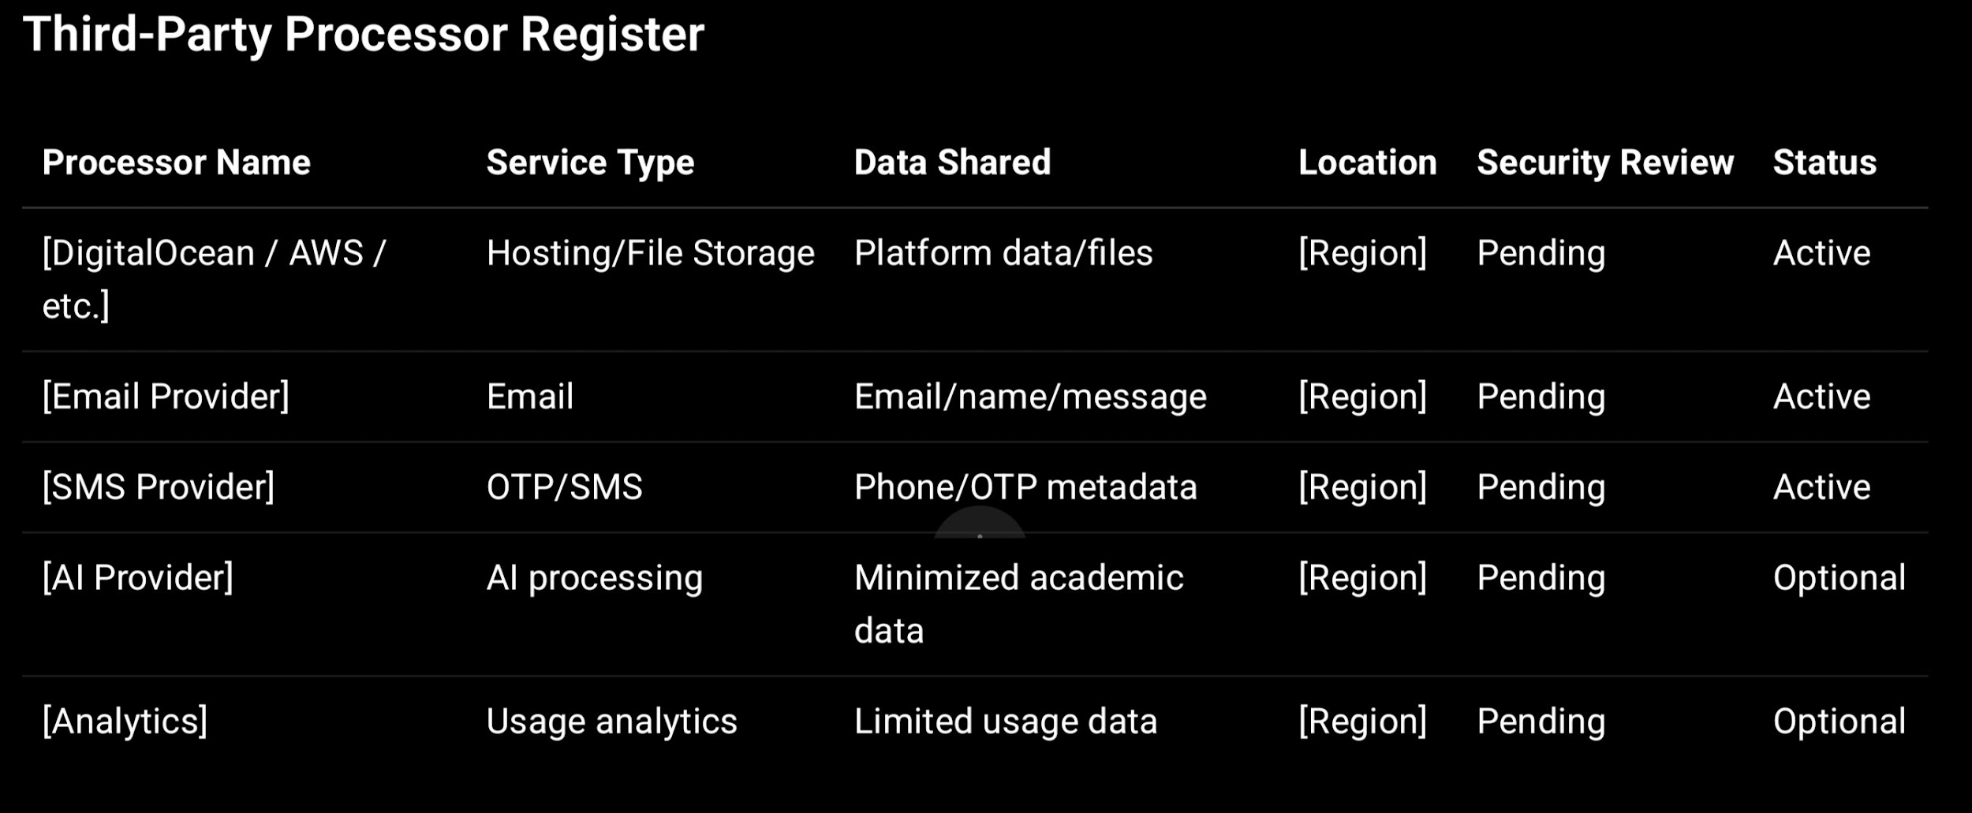

---

16. Data Retention

SproutSong shall retain School Data only as long as necessary for the agreed purpose, school policy, legal requirement, audit requirement, security requirement, or platform operation.

Suggested retention structure:

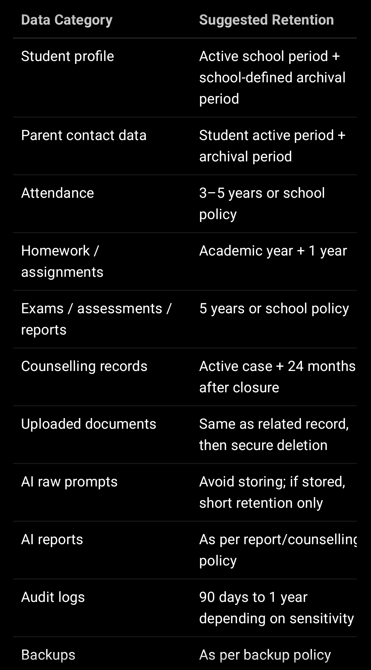

Your form security document recommends retaining active counselling records for the counselling period plus 24 months after closure, deleting drafts after 30 days, purging uploaded documents with related records, nulling financial data on case closure, and deleting within 72 hours of a valid erasure request where applicable.

---

17. Deletion, Correction, and Access Requests

The School and SproutSong shall cooperate to respond to:

Parent/guardian access requests
Student data correction requests
Deletion requests
Consent withdrawal requests
Grievance requests
AI report correction requests
Document deletion requests

Where the School is responsible for verifying the requester’s authority, the School shall assist SproutSong in confirming identity and eligibility.

SproutSong may retain certain records where required for:

Academic records
Legal obligations
Audit logs
Security investigations
Dispute resolution
Backup recovery
School compliance
Financial/payment records, if applicable

SproutSong’s DPDP/security report recommends a data_requests collection covering access, correction, deletion, withdrawal, and grievance requests, with statuses such as pending, in review, completed, and rejected.

—

18. Data Breach and Security Incident Response

A security incident may include:

Student data visible to wrong user
Parent accessing another child’s report
Teacher accessing another school’s data
Public document exposure
Database leak
Wrong report sent to wrong recipient
Sensitive data in logs
Unauthorised data export
Compromised admin account
AI report exposed before review

SproutSong shall take reasonable steps to:

- Identify the incident.
- Contain the exposure.
- Revoke affected tokens/sessions where necessary.
- Disable affected routes/features where necessary.
- Patch the vulnerability.
- Assess affected users and data categories.
- Notify the School where required.
- Support the School in parent/regulatory communications where required.
- Record the incident and corrective actions.
- Improve controls to prevent recurrence.

Your breach guidance lists immediate containment steps such as disabling affected APIs, revoking tokens, changing credentials, blocking public access, patching vulnerabilities, assessing whether children were affected, and improving validation/access checks after the incident.

—

19. Confidentiality

Both parties shall keep confidential:

Student data
Parent/guardian data
Teacher/staff data
School operational data
Counselling records
Reports
Documents
Credentials
Security information
Platform configurations
Incident details
Commercial terms

Access to confidential data shall be limited to authorised personnel with a legitimate need.

—

20. Subcontractors and Staff Access

SproutSong shall ensure that employees, contractors, support staff, developers, vendors, or subcontractors with access to School Data:

Are authorised
Have a legitimate need
Are bound by confidentiality
Follow access-control policies
Do not use data for personal or unrelated purposes
Are subject to reasonable security controls

Developers should not access production student data by default. SproutSong’s access matrix recommends that technical support have limited support access with approval and logging, and developers have no production personal data by default.

—

21. Data Location and Cross-Border Processing

SproutSong shall document where School Data is stored and processed, including:

Application database
File storage
Backups
Logs
AI providers
Email/SMS providers
Analytics providers

If School Data is stored or processed outside India, SproutSong shall disclose this to the School where required and maintain appropriate safeguards.

SproutSong’s DPDP/security report recommends documenting whether data is stored in India, outside India, or processed through third-party services.

—

22. Data Return and Deletion on Termination

Upon termination of the School’s use of SproutSong, the School may request:

Export of School Data
Deletion of School Data
Retention for a defined period
Transfer to another authorised system
Deactivation of user accounts

SproutSong shall delete or return School Data within a reasonable period, subject to:

Legal retention
Academic record requirements
Audit logs
Security logs
Backup retention cycles
Dispute resolution
Payment/accounting requirements

Suggested clause:

Upon termination, SproutSong shall, upon written request from the School, delete or return School Data within [30–90] days, except where retention is required for legal, academic, audit, backup, security, or dispute-resolution purposes.

—

23. Audit and Compliance Review

The School may request reasonable information about SproutSong’s data protection practices, including:

Security policies
Access control model
Data retention policy
Breach response process
Third-party processor list
AI processing controls
File storage controls
Consent handling mechanism

SproutSong may provide summaries, reports, or compliance documents rather than direct access to production systems.

The internal readiness guide recommends outputs such as a data inventory sheet, user role/access matrix, third-party processor list, API security checklist, consent compliance report, file upload security report, breach response SOP, and final DPDP readiness report.

—

24. Liability and Responsibility

Each party shall be responsible for its own acts, omissions, negligence, unauthorised access, or breach of this Agreement.

The School is responsible for:

Lawful collection of data before sharing
Parent/guardian consent where required
Correct role assignment for school users
Accuracy of submitted data
School staff misuse
Prompt removal of departed staff access
Review of AI-assisted outputs before use

SproutSong is responsible for:

Secure processing of School Data
Platform-level access controls
Secure storage
Protection against unauthorised system access
Technical security controls
Breach response support
Data deletion/retention implementation
Subprocessor safeguards

Neither party shall use student data in a manner that is unlawful, harmful, discriminatory, or outside the agreed purpose.

—

25. Notices and Contact Points

For privacy/data requests

privacy@sproutsong.com

For support

support@sproutsong.com

For security incidents

security@sproutsong.com

School contact

School Privacy Contact: [Name / Email / Phone]
School Admin Contact: [Name / Email / Phone]
Authorised Representative: [Name / Designation]

—

26. Term and Termination

This Agreement begins on the Effective Date and remains active while the School uses SproutSong services, unless replaced or terminated by a written agreement.

Either party may terminate according to the main service agreement, subscription terms, school onboarding terms, or written notice.

Data return/deletion obligations will survive termination.

Confidentiality, security, audit, breach response, and data protection obligations shall survive termination where required.

—

27. Governing Law and Jurisdiction

This Agreement shall be governed by the laws of India unless otherwise agreed in writing.

Any dispute shall be subject to the jurisdiction of courts located at:

[City, State, India]

Internal note: Add final jurisdiction after legal review.

—

28. Signature Block

For the School / Institution

School Name: _____________________________
Authorised Signatory Name: _________________
Designation: ______________________________
Email: ___________________________________
Signature: ________________________________
Date: ____________________________________

For SproutSong / SproutMentors

Entity Name: ______________________________
Authorised Signatory Name: _________________
Designation: ______________________________
Email: ___________________________________
Signature: ________________________________
Date: ____________________________________

Annexure A — Data Processing Details

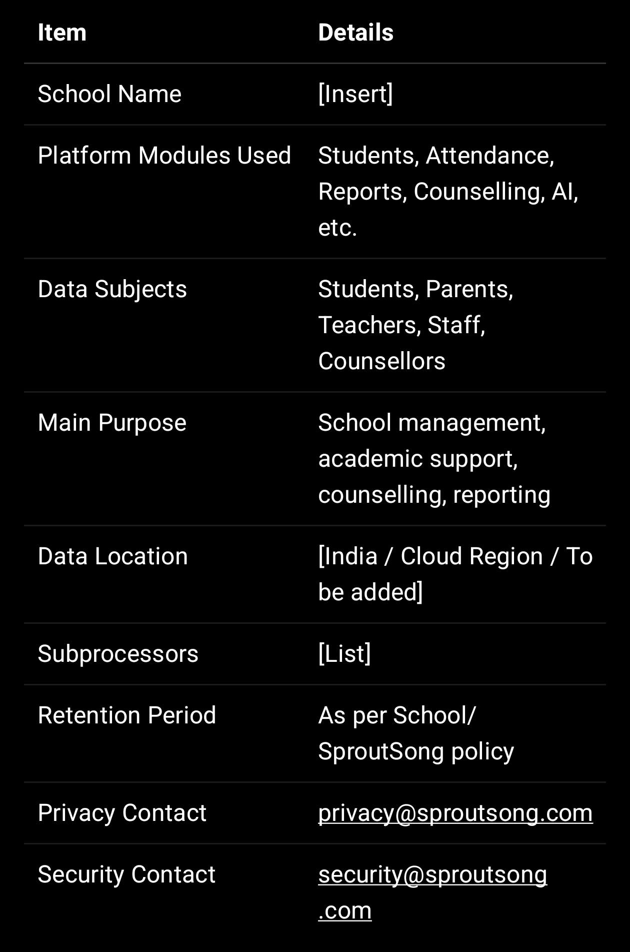

Annexure B — Data Categories

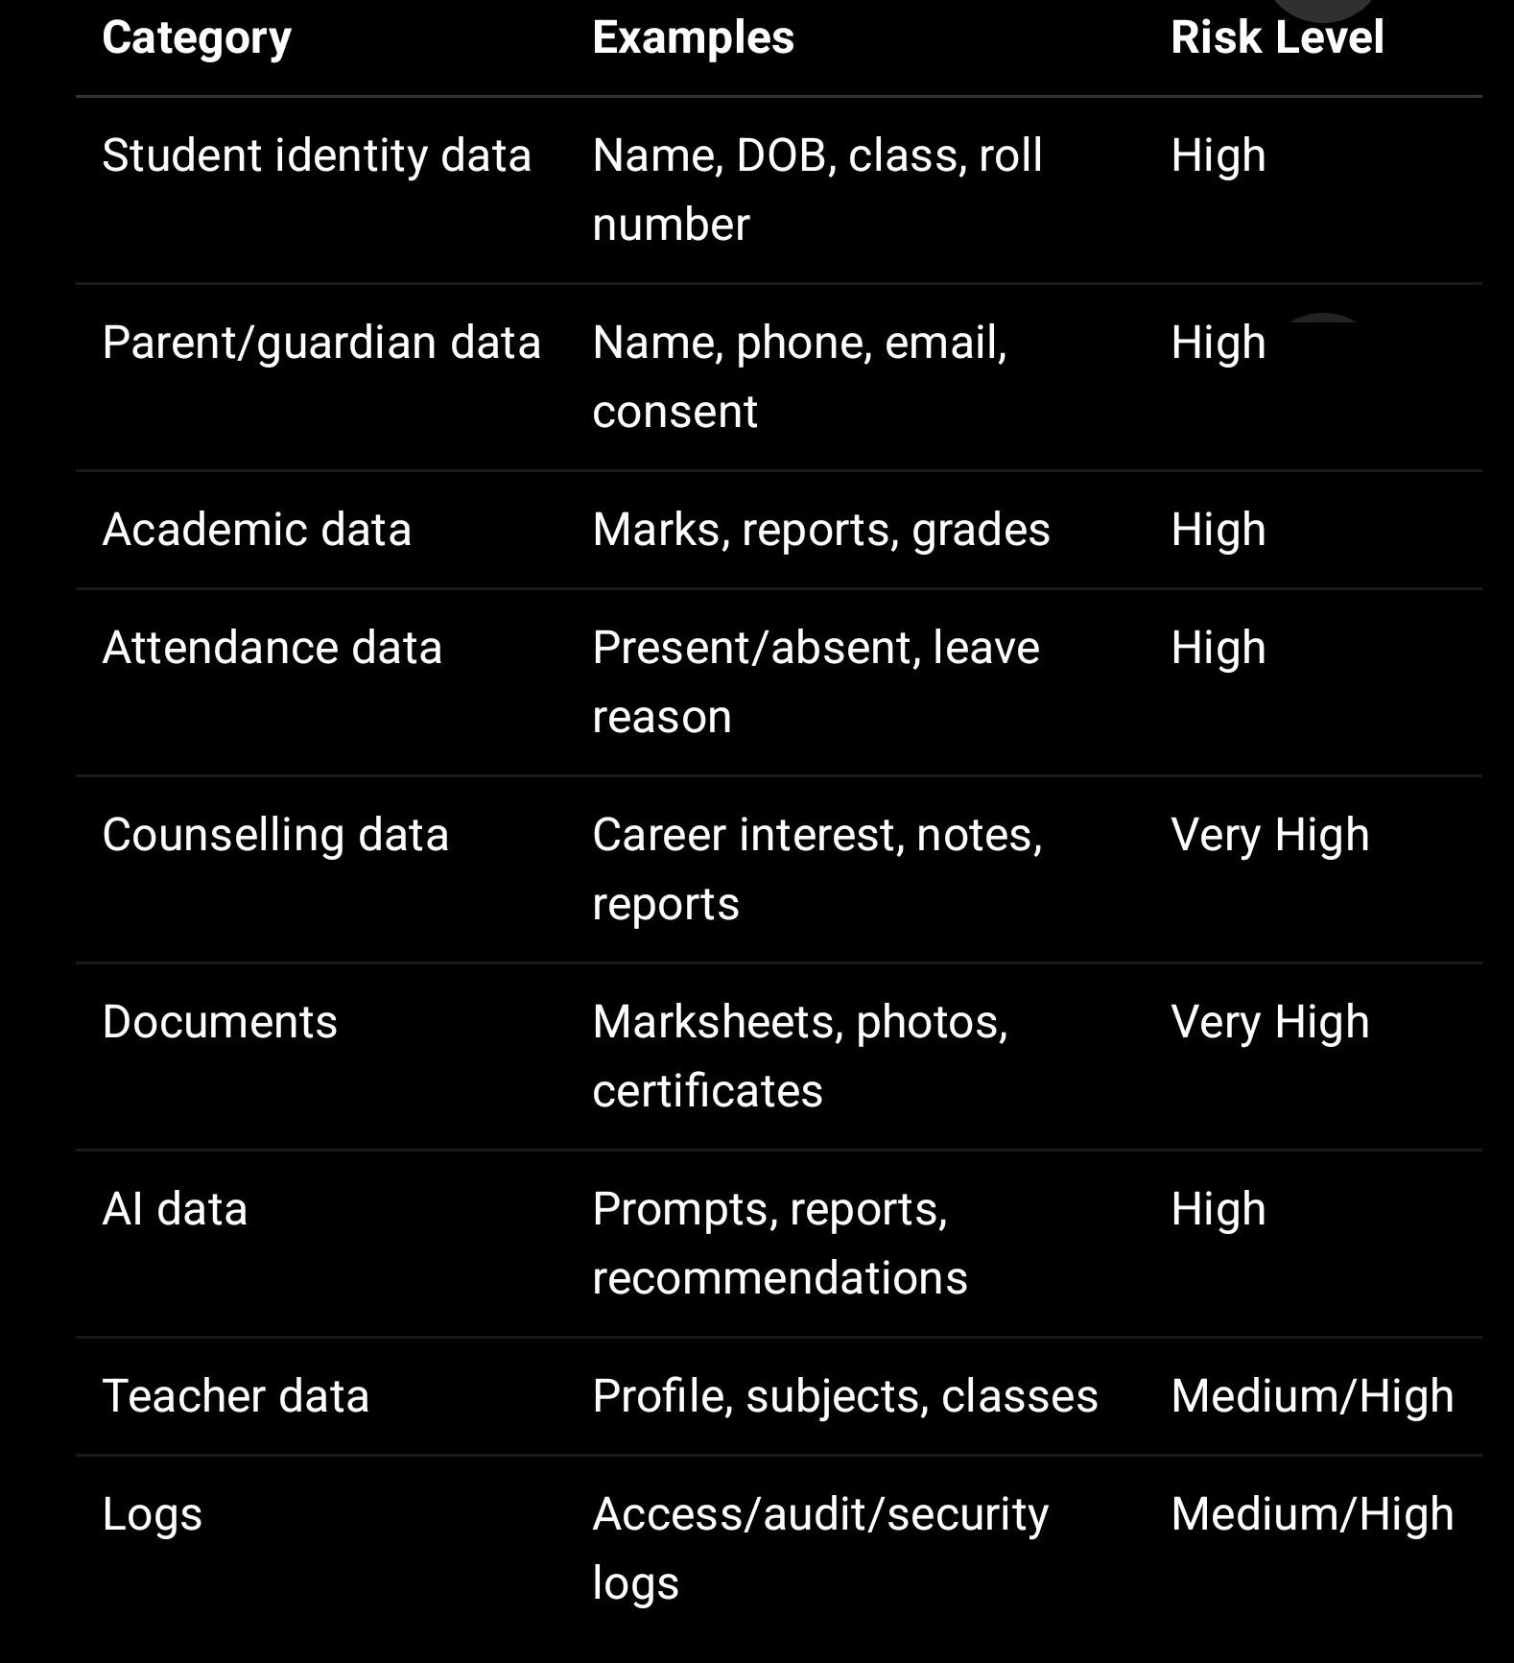

Annexure C — Minimum Security Controls

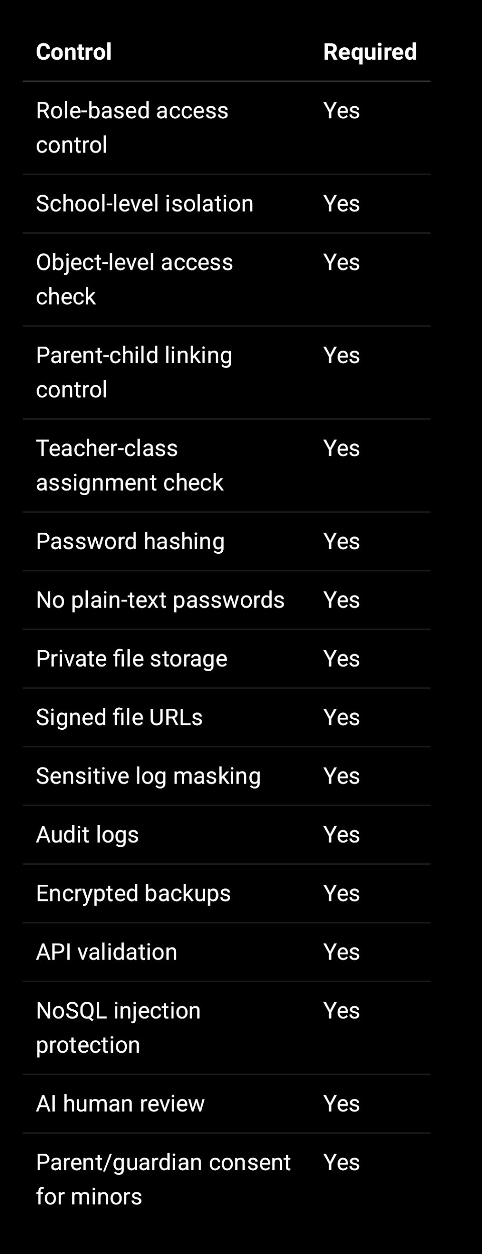
Annexure D — School Consent Confirmation

The School confirms that it has authority to share student, parent, teacher, staff, academic, attendance, counselling, document, and operational data with SproutSong / SproutMentors for agreed educational and administrative purposes.

The School confirms that, where required, it has obtained parent/lawful guardian consent for processing children’s data.

The School agrees to notify SproutSong if any consent is withdrawn, if any data is inaccurate, or if any user access should be removed.

Annexure E — AI Processing Addendum

If AI features are enabled, the School agrees that:

- AI outputs are assistive and not final decisions.
- Student data should be minimised before AI processing.
- Personal identifiers should be removed where possible.
- AI reports must be reviewed before sharing with students/parents.
- AI must not be used for harmful profiling or negative labelling.
- AI should not be the sole basis for stream, course, counselling, or disciplinary decisions.
- Parents/students may request clarification or correction of AI-assisted reports.

Annexure F — Breach Notification Template

Subject: Security Incident Notification — [School Name]

Dear [School Contact],

We are notifying you of a suspected/confirmed security incident involving [brief description].

Date/time identified:
Affected module:
Data potentially affected:
Number of affected records:
Whether children’s data was involved:
Containment steps taken:
Current status:
Recommended school action:
Next update timeline:

Regards,
SproutSong Security / Compliance Team
security@sproutsong.com
privacy@sproutsong.com

Annexure G — Internal Compliance Tracking Fields

When this DPA is signed, store it in your compliance document system:

{
documentType: "SCHOOL_DATA_PROCESSING_AGREEMENT",
version: "v1.0",
schoolId: ObjectId,
schoolName: String,
status: "SIGNED",
effectiveDate: Date,
expiryDate: Date,
signedBySchool: {
name: String,
designation: String,
email: String,
signedAt: Date
},
signedBySproutSong: {
name: String,
designation: String,
email: String,
signedAt: Date
},
linkedPrivacyPolicyVersion: "v1.0",
linkedTermsVersion: "v1.0",
linkedChildDataPolicyVersion: "v1.0",
signedDocumentUrl: String,
createdAt: Date,
updatedAt: Date
}

—

Final Publishing / Usage Checklist

Before using this DPA with schools:

- Add official SproutSong legal entity name.
- Add registered address.
- Add final jurisdiction.
- Add school signatory fields.
- Add final data retention schedule.
- Add third-party processor list.
- Add cloud/storage region details.
- Link Privacy Policy.
- Link Terms & Conditions.
- Link Child Data Protection Policy.
- Link AI Usage Disclaimer.
- Add breach notification timeline after legal review.
- Store signed copy in compliance records.
- Add DPA status to school onboarding checklist.
- Review annually or after major platform/privacy changes.

